Sunday June 29,2025  An old fashion Community Ice Cream Social & Membership Drive  An old Fashion Community Ice Cream Social in the park on Sunday after Church. We would like to invite our present members to meet the board and learn how to get involved with the museum and other organizations.  If you are a member, you will receive your tickets to use for a Hot Dog, Chips, a drink, and a scoop of ice cream or purchase a membership for half price and get your tickets. We want to share Pendleton’s History a chance to learn about other organizations, being a volunteer and helping to build a stronger community through networking.  Join us for a fun family day in the park  Not a member, you may purchase tickets:  5 for $5.00 or 15 for $10.00  If you want to setup in the park with your organization there is no charge.  Bring your own table, chairs and a popup tent.  Contact Pendleton Air Museum at info@pendletonairmuseum.com  Text: 541-561-8488 or Call: 541-276-6156  Don’t forget to purchase your Raffle Tickets  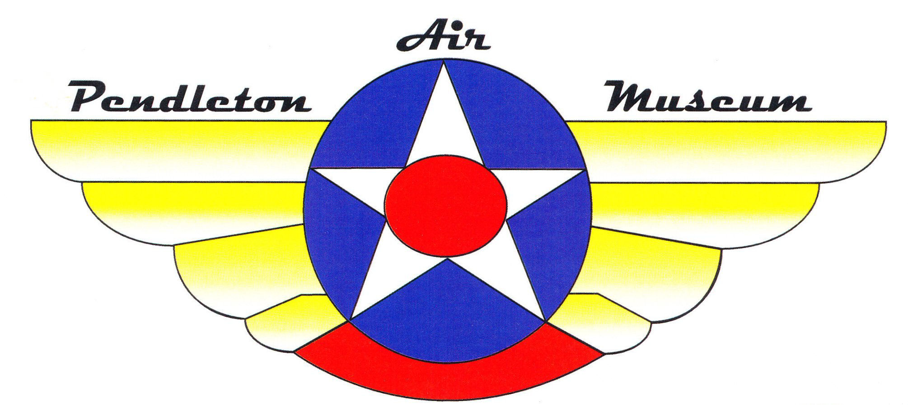 | An Old Fashion Community  Ice Cream Social &  Membership Drive  Family’s getting together in  Roy Raley Park  Meet & Greet to share Pendleton’s great History and become a member for half price.  Learn about local organization and volunteering  Lots of fun for all the family. Great Ice Cream & Hot Dogs and more.  Pendleton Air Museum  In Roy Raley Park at  1205 SW Court Ave.  Call (541) 276-6156  info@pendletonairmuseum.com  Sunday June 29, 2025  12:00 pm to 3:00 pm

